**[Route To Label Node Routing mode behavior](https://eaideveloper.wordpress.com/2014/11/09/route-to-label-node-routing-mode-behavior/)**

Posted on [November 9, 2014](https://eaideveloper.wordpress.com/2014/11/09/route-to-label-node-routing-mode-behavior/)by [vishnu](https://eaideveloper.wordpress.com/author/vishnurajnr/" \o "View all posts by vishnu)

Route to Label node in IIB/WMB can be used to dynamically route the message based on the message content. The combination of **Route to Label** and the **Label**node will do this dynamic routing. In order to use route to Label node, we need to set the **destination list**in the Localenvironment message tree using a compute node before passing the message to the route to label node. In the Basic tab of the route to Label node, there is the **mode**property specified and by default it is been selected as ‘**Route to Last**‘ This post is to elaborate the Routing mode behavior in bit detail. As per the InfoCenter, this property signifies:

*This property controls how the RouteToLabel node processes the items in the local environment that is associated with the current message . Valid values are: • Route To First: removes the first item from the local environment. The current message is routed to the Labelnode that is identified by labelName in that list item. • Route To Last (the default): removes the last item from the local environment. The current message is routed to the Label node that is identified by labelName in that list item.*

To Elaborate this in more details, let me introduce a sample message flow having a compute node attached before the route to label node and the compute mode set to ‘LocalEnvironment and Message’. In the compute node I have set :

|  |  |
| --- | --- |
| 1  2  3  4  5  6  7  8  9 | IF InputRoot.XMLNSC.NEWS.SPORTS = 'HOCKEY' THEN             SET OutputLocalEnvironment.Destination.RouterList.DestinationData[1].labelName = 'HOCKEY';             SET OutputLocalEnvironment.Destination.RouterList.DestinationData[2].labelName = 'HOCKEY1';             SET OutputLocalEnvironment.Destination.RouterList.DestinationData[3].labelName = 'HOCKEY2';          ELSE             SET OutputLocalEnvironment.Destination.RouterList.DestinationData[1].labelName = 'FOOTBALL';             SET OutputLocalEnvironment.Destination.RouterList.DestinationData[2].labelName = 'FOOTBALL1';             SET OutputLocalEnvironment.Destination.RouterList.DestinationData[3].labelName = 'FOOTBALL2';          END IF; |

In the Rote to label node I have set the mode as ‘Route to Last’ and I have put the sample message as below:

|  |  |
| --- | --- |
| 1  2  3 | <NEWS>  <SPORTS>HOCKEY</SPORTS>  </NEWS> |

The OutputLocalEnvironment **before**the Route to Label node contains all 3 destination lists:[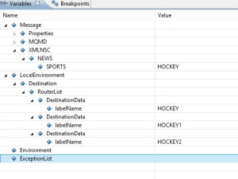](https://eaideveloper.files.wordpress.com/2014/03/routelabel_debug1.jpg)And the message got route to the ‘**HOCKEY2**‘ Label since the mode selected as ‘**Route to Last**‘. And the last child in the LocalEnvirronment Tree (means OutputLocalEnvironment.Destination.RouterList.DestinationData[3].labelName = ‘HOCKEY2’ is been **removed**after the reaching the label node).[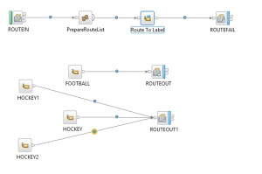](https://eaideveloper.files.wordpress.com/2014/03/routelabel_routetolastflow.jpg)[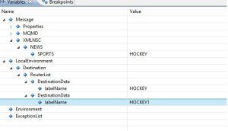](https://eaideveloper.files.wordpress.com/2014/03/routelabel_debug2.jpg)If I change the mode to ‘**Route to First**‘, the same message got route to the label ‘**HOCKEY**‘ and the **first child got removed** from the LocalEnvirronment Tree ((means OutputLocalEnvironment.Destination.RouterList.DestinationData[1].labelName = ‘HOCKEY’ is been removed after the reaching the label node).[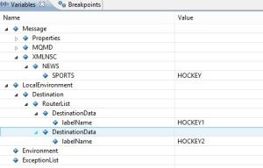](https://eaideveloper.files.wordpress.com/2014/03/routelabel_debug3.jpg)[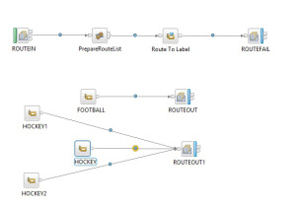](https://eaideveloper.files.wordpress.com/2014/03/routelabel_flow.jpg)If the OutputLocalEnvironment RouterList doesnot contain a List, then the Route To Label Node’s Mode property ddont have any impact. It will always route to the given label since there is only one item in the destinationlist eg:

|  |  |
| --- | --- |
| 1 | SET OutputLocalEnvironment.Destination.RouterList.DestinationData.labelName = 'HOCKEY'; |

The above will always route to the label node ‘**HOCKEY**‘ no matter the route to label mode is ‘**Route to First**‘ or ‘**Route to Last**‘. **References:** **[IIB InfoCenter](http://www-01.ibm.com/support/knowledgecenter/SSMKHH_9.0.0/com.ibm.etools.mft.doc/ac04820_.htm?lang=en)** [**MQ Series net**](http://www.mqseries.net/phpBB2/viewtopic.php?p=336051&sid=099999b2df7a51786e1861b6e26ba67f%20)